Regulatory Committee
Meeting to be held on 6 April 2016

Electoral Division affected:
Rossendale West, Rossendale South

Wildlife and Countryside Act 1981
Definitive Map Modification Order Investigation
Addition of and upgrade to Public Bridleway from Edenfield to Helmshore Road, Haslingden passing through Irwell Vale
File No. 804/548
(Annex ‘A’ refers)

Contact for further information:
Megan Brindle, 01772 535604, Paralegal Officer, County Secretary and Solicitors Group, megan.brindle@lancashire.gov.uk
Jayne Elliott, 07917 836626, Public Rights of Way, Planning & Environment Group, Jayne.elliott@lancashire.gov.uk

Executive Summary

Application for the addition of and upgrade to public bridleway of a route from Edenfield to Helmshore Road, Haslingden passing through, Irwell Vale in accordance with File No. 804-548.

This would be implemented by:

- Upgrade to public bridleway part of Ramsbottom Footpath 128 between point 1 and point B.
- Upgrade to public bridleway part of Ramsbottom Footpath 130 between points B-C-D.
- Upgrade to public bridleway part of Ramsbottom Footpath 131 between points E-D and points D-F.
- The addition of a public bridleway from a point on Ramsbottom Footpath 131 from point F to a point on Ramsbottom Footpath 130 at point G.
- Upgrade to public bridleway part of Ramsbottom Footpath 130 between point G and point H.
- The addition of a public bridleway from a point on Ramsbottom Footpath 130 at point H along Aiken Street and Milne Street to the junction with Haslingden Footpath 387 at point I.
- Upgrade to public bridleway the whole of Haslingden Footpath 387 between point I and point J.
- Upgrade to public bridleway the whole of Haslingden Footpath 388 between point J and point K.

n.b. it would not be correct to add A-1 as bridleway because it is a carriageway but it is not possible to delete it from the Definitive Map and Statement due to a deficiency in the legislation.

Recommendation

1. That the application for the addition of and upgrade to public bridleway of a route from Edenfield to Helmshore Road, Haslingden passing through Irwell Vale, in accordance with File No. 804-548, be accepted.

2. That Orders be made pursuant to Section 53 (2)(b) and Section 53 (3)(b) and Sections 53 (c)(i)(ii) and (iii) of the Wildlife and Countryside Act 1981 to add and upgrade to public bridleway the route from Edenfield to Helmshore Road, Haslingden passing through Irwell Vale on the Definitive Map and Statement of Public Rights of Way as shown on the Committee Plans between points 1-B-C-D, D-E and points D-F-G-H-I-J-K.

3. That being satisfied that the higher test for confirmation can be met the Orders be promoted to confirmation.

Background

An application under Schedule 14 of the Wildlife and Countryside Act 1981 has been received for the addition of and upgrade to public bridleway of a route from Edenfield to Helmshore Road, Haslingden passing through Irwell Vale as shown between points A-B-C-D, D-E, and D-F-G-H-I-J-K on the Committee plans, on the Definitive Map and Statement of Public Rights of Way.

The County Council is required by law to investigate the evidence and make a decision based on that evidence as to whether a public right of way exists, and if so its status. Section 53(3)(b) and (c) of the Wildlife and Countryside Act 1981 set out the tests that need to be met when reaching a decision; also current Case Law needs to be applied.

An order for upgrading a way shown on the Definitive Map and Statement will only be made if the evidence shows that:

"it ought to be there shown as a highway of a different description"

An order will only be made to add a public right of way to the Definitive Map and Statement if the evidence shows that:
- A right of way “subsists” or is “reasonably alleged to subsist”
or
- “the expiration… of any period such that the enjoyment by the public…raises a presumption that the way has been dedicated as a public path or restricted byway”

When considering evidence, if it is shown that a highway existed then highway rights continue to exist (“once a highway, always a highway”) even if a way has since become disused or obstructed unless a legal order stopping up or diverting the rights has been made. Section 53 of the Wildlife and Countryside Act 1981 (as explained in Planning Inspectorate’s Advice Note No. 7) makes it clear that considerations such as suitability, the security of properties and the wishes of adjacent landowners cannot be considered. The Planning Inspectorate’s website also gives guidance about the interpretation of evidence.

The County Council’s decision will be based on the interpretation of the evidence discovered by officers and documents and other evidence supplied by the applicant, landowners, consultees and other interested parties produced to the County Council before the date of the decision. Each piece of evidence will be tested and the evidence overall weighed on the balance of probabilities. It is possible that the Council’s decision may be different from the status given in any original application. The decision may be that the routes have public rights as a footpath, bridleway, restricted byway or byway open to all traffic, or that no such right of way exists. The decision may also be that the routes to be added or deleted vary in length or location from those that were originally considered.

Consultations

Rossendale Borough Council has been consulted and no response has been received so it is assumed they have no comments to make.

There is no Parish Council for this area

Claimant/Landowners/Supporters/Objectors

The evidence submitted by the claimant/landowners/supporters/objectors and observations on those comments is included in ‘Advice – Head of Service – Legal and Democratic Services Observations’.

Advice

Head of Service – Planning and Environment

The total length of the route is approximately 2.3km long and is shown spanning 5 numbered 1:2500 scale Committee plans. The route is shown by a thick dashed line and the key points denoting the start and finish points and changes in recorded legal status are mostly marked with capital letters. Additional features which can be identified on site or in the map and documentary evidence and which are referred to in the report are mostly referenced numerically.

Point | Grid Reference (SD) | Description
A | 7987 1983 | Open junction of Church Lane with Market Street adjacent to Edenfield Parish Church
B | 7960 1986 | Point at which route turns north east adjacent to the A56 (junction of Ramsbottom Footpaths 128 & 130)
C | 7963 1991 | Point at which route of Ramsbottom Footpath 130 diverges
D | 7968 2010 | Junction of Ramsbottom Footpaths 130 and 131 on Hardsough Lane
E | 7971 2025 | Open junction of Ramsbottom Footpath 131 with Blackburn Road adjacent to A56
F | 7928 2014 | Unmarked point on Ramsbottom Footpath 131 where the route under investigation leaves the recorded route of the footpath to continue west across the railway line via a level crossing)
G | 7925 2016 | Unmarked point on tarmac section of route under investigation west of level crossing where recorded section of Ramsbottom Footpath 130 re-joins it
H | 7923 2021 | Unmarked point on Ramsbottom Footpath 130 immediately east of Irwell Vale Bridge
I | 7900 2030 | Unmarked point on track at junction with Haslingden Footpath 387
J | 7866 2050 | Junction of Haslingden FPs 387, 386 and 388 Haslingden adjacent to Hillcrest
K | 7827 2045 | Open junction with Helmshore Road at Irongate Barn

Additional features numbered on the Committee plans

1 | 7981 1983 | Western end of adopted section of Church Lane (U2979)
2 | 7974 1984 | Point from which Church Lane (Ramsbottom Footpath 128) was stopped up by The Manchester – Burnley Trunk Road (Edenfield – Rawtenstall Level Crossing By-Pass) (Side Roads) Order 1964 to allow for the construction of the A56
3 | 7964 1993 | The route passes between concrete gateposts with remains of adjacent pedestrian gate
4 | 7965 1998 | Route passes between remains of gateposts
5 | 7959 2013 | Point from which there is access from the route under investigation to row of 5 terrace houses and Grange House
6 | 7957 2015 | Metal field gate across the route
7 | 7948 2020 | Point from which there is access from the route under investigation to Hardsough Farm
8 | 7944 2027 | Wooden post located in centre of track to prevent vehicular access beyond which there is a sharp corner beyond which the route was shown unbounded on the Tithe Map and early OS maps
9 | 7933 2020 | Wooden post located in centre of the track to prevent vehicular access north east of row of 5 terraced houses and boundary of Finance Act hereditament
10 | 7924 2018 | Route under investigation crossed by Ramsbottom Footpath 125 on Hardsough Fold
11 | 7916 2026 | Junction of Aitken Street and Bowker Street in Irwell Vale
12 | 7911 2022 | Junction of Bowker Street, Milne Street and Haslingden Footpath 390 in Irwell Vale
13 | 7888 2037 | Private railway bridge (Ref: Overbridge No. 59) owned by Railway Paths Ltd and carrying Haslingden Footpath 387.
14 | 7872 2047 | Metal field gate and adjacent stile across the route
15 | 7862 2050 | Position of boundary on Tithe Map, line across route on early OS maps and boundary of hereditament on Finance Act plan.
16 | 7854 2050 | Line across route on OS maps.
17 | 7840 2049 | Line across route on OS maps and boundary of hereditament on Finance Act plan.

Description of the Route under investigation, 'the Route', as currently observed.

A site inspection was carried out on Friday 26th February 2016.

The full length of the route is accessible on foot and at the time of inspection there was evidence that it was also being used on horseback and bicycle. The Route is a substantial length – approximately 2.3 km - and passes through the hamlet of Irwell Vale over land within the parishes of both Ramsbottom and Haslingden. It is crossed by the A56 trunk road, East Lancashire Railway, the River Irwell and a dismantled railway.

Because of its length, the description of the Route has been broken down into manageable sections which correspond to the parts of the Route which are currently recorded on the Definitive Map as individually numbered footpaths and sections with no recorded legal status. The start and finish points of these sections are all marked on the plan with capital letters and other features noted in the report are marked by a numbers.

The Route is described from east to west:

Ramsbottom Footpath 128 between point A and point 1 on Committee plan 1/5

The Route commences at an open junction with Market Street, Edenfield (Ramsbottom), adjacent to Edenfield Parish Church and is signed as 'Church Lane'. From point A the Route is tarmacked with an adjacent footway and street lights and provides access to the church, graveyard and to houses on Church Court.

The Route is tarmacked and forms part of Church Lane – a publicly maintainable highway currently recorded as part of Ramsbottom Footpath 128 but also recorded on the List of Streets (U2979).

On the approach to point 1 there is a sign indicating that beyond that point the continuation of the Route is a private road and stating that there is no parking beyond point 1 and that 24 hour access is required for wide load farm machinery. The sign appears to be quite new.

Ramsbottom Footpath 128 between point 1 and point B on Committee plan 1/5

From point 1 the surface of the Route deteriorates to patchy tarmac with numerous potholes. The Route narrows to approximately 3.5 metres enclosed between walls and fences to point 2 where the lane splits with the more south westerly providing access to Edenfield Nursing Home. From point 2 the Route continues in a westerly direction along a tarmac road, rising gradually uphill along a man-made ramp and fenced on either side as it crosses the A56 Trunk Road via a substantial vehicular bridge. Signs at either end of the bridge indicate that there is a weight restriction relating to use of the bridge and that there should only be one vehicle on the bridge at a time. Beyond the western end of the bridge the road splits again at point B with a road continuing south to provide access to four properties at Great Hey Farm (and recorded as Ramsbottom Footpath 128) while the Route continues north east (Ramsbottom Footpath 130).

Ramsbottom Footpath 130 (part) between point B and point C and shown on Committee plan 1/5

From point B the Route continues in a north easterly direction. It is fenced on either side and the tarmac is becoming overgrown along either side and is covered in moss in places suggesting little or infrequent vehicular use.

From point B the Route descends gently downhill along a man-made ramp constructed as part of the A56 trunk road accommodation works, to point C. Adjacent to the Route at point C a public footpath signpost is located pointing west down a flight of overgrown concrete steps which provide access along part of Ramsbottom Footpath 130.

Ramsbottom Footpath 130 (part) between point C and point D and shown on Committee plan 1/5

At point C Ramsbottom Footpath 130 splits and the Route continues along a compacted stone track fenced on either side to point 3 where it passes through two concrete gateposts (no gate) alongside which there is the overgrown remains of a narrower pedestrian gate.

Beyond point 3 the Route continues, running adjacent to the A56 trunk road, along a stone surfaced track fenced from the trunk road but open to rough grassland to the west. After a further 50 metres the Route passes through another set of gateposts (no gate) at point 4 and then continues as an enclosed Route fenced on either side between the A56 trunk road and a field grazed by horses. The compact stone surface of the Route is muddy in places and at the time of inspection hoof prints and bicycle tracks were evident on the ground.

At point D the Route joins Ramsbottom Footpath 131 known as Hardsough Lane at an open junction.

Ramsbottom Footpath 131 between point E and point D and shown on Committee plan 1/5

Hardsough Lane commences at an open junction with Blackburn Road at point E. A street sign is located at the junction together with signs indicating that the Route is a public footpath and not a through route for vehicles.

The Route follows a wide tarmac surfaced track in a southerly direction parallel to the A56 trunk Road. The tarmac surface is potholed in places and there is recent evidence of use by vehicles and horses. The Route is fenced on either side and after approximately 160 metres it meets Ramsbottom Footpath 130 at point D.

Ramsbottom Footpath 131 from Point D to point F and shown on Committee plans 1/5 and 2/5

The Route, known as Hardsough Lane, continues from point D in a general north westerly direction fenced on either side and surfaced with tarmac which is broken and potholed in places. It provides vehicular access to a number of properties and fields and passes Grange House and a row of 5 terraced houses at point 5 and continues past the houses to pass through a metal field gate at point 6. It continues as a bounded track along a compact stone and concrete surfaced track to point 7 from where there is direct access from the Route to Hardsough Farm.

From point 7 the Route turns to run in a more north north westerly direction. It continues as a bounded track but the surface is less well maintained consisting mainly of compacted earth and stone with evidence of recent water erosion. The Route descends gradually to point 8 where a wooden post has been placed in the centre of the track to prevent vehicular use of the section of Route beyond.

Just past the wooden post the Route turns sharply to continue in a south westerly direction descending quite steeply downhill to point 9. Between point 8 and point 9 the surface of the Route has been damaged by the flow of water along it. A series of wooden grips has been placed across the Route to attempt to reduce the flow of water and to prevent the stone surface of the path being washed away. Recent evidence of use of the Route by cycles could be seen.

At point 9 a further wooden post has been erected in the centre of the Route to prevent vehicular use between points 8 and 9.

Beyond point 9 the Route passes to the side and along the front of a row of terraced properties. A car was parked on the Route adjacent to property number 269 reducing the width of the Route and further cars were parked along the front of the terrace although the greater width along the front of the terraced meant that it was still easy to pass alongside those.

The Route continues along the front of the terraced properties adjacent to the single track railway now operated as the East Lancashire Railway between Bury and Rawtenstall to point F by the gate to the level crossing.

Unrecorded Route from point F to point G and shown on Committee plan 2/5

From point F Ramsbottom Footpath 131 continues south west parallel to the railway whereas the Route turns to continue in a north westerly direction across the railway via a level crossing.

The railway crossing is gated at either side and signs indicate that pedestrians must use the subway provided north east of point F and that if the crossing is being used with vehicles or animals the far gate must be opened before crossing.

The Route continues a further 15m past the entrance to a car park and railway station on the south to join the line of Ramsbottom Footpath 130 at an unmarked point on a tarmac road (G).

Ramsbottom Footpath 130 between points G and H shown on Committee plan 2/5

From point G the Route crosses a wide open area which is tarmac extending in a generally north westerly direction to Hardsough Court where it is crossed by Ramsbottom Footpath 125 at point 10. It then follows the tarmac road adjacent to the terraces on Hardsough Fold to point H at the south east end of Irwell Vale Bridge from where the recorded line of Ramsbottom 130 lies, probably in error, diagonally across the river.

Unrecorded route through Irwell Vale from point H to point I and shown on Committee plan 3/5

From point H the Route crosses Irwell Vale Bridge and continues along Aitken Street to point 11 opposite Ogden Bridge which connects to the only recorded public vehicular road providing access to the hamlet (Irwell Vale Road).

From point 11 the Route turns to continue in a south westerly direction passing between two rows of terraced houses along Bowker Street to the entrance to Irwell Vale Methodist church and Ramsbottom Footpath 390 at point 12. It then continues in a north westerly direction as Milne Street, rising gradually uphill past a number of further residential properties from the end of which the surface changes to compacted stone and earth as it continues to point I.

Haslingden Footpath 387 between point I and point J and shown on Committee plan 3/5 and 4/5

From point I the Route passes through wooden gateposts (with an old metal gate lying on the ground) and a wooden stile to the north east side of the gateposts.

The Route continues uphill out of Irwell Vale on a bounded compacted earth and stone track in a north westerly direction to cross a dismantled railway via a substantial stone bridge at point 13.

It then flattens out and continues as a bounded track to point 14 where it is crossed by a metal field gate and adjacent wooden stile. Approximately 65 metres further on the Route meets point J at the junction of the ways recorded as Haslingden Footpaths 386, 387 and 388.

Haslingden Footpath 388 between point J and point K and shown on Committee plan 4/5 and 5/5

From point J the Route continues in a generally westerly direction along a compacted earth and stone surfaced track past a number of properties at Raven Shore. It continues as a bounded track with fields grazed by horses on either side and then passes between further properties at Iron Gate to exit onto Helmshore Road at an open junction at point K.

Map and Documentary Evidence

An application was considered by Committee at their meeting of 12 November 2008 to consider whether part of the Route (between points 10-H-11-12) should be recorded on the Definitive Map and Statement of Public Rights of Way as a Byway Open to All Traffic. The application was rejected by Committee and a copy of the report is attached as Appendix 1.

The hamlet of Irwell Vale stands where two rivers, the Ogden and the Irwell converge, and only came into being in the early 1800s as a result of the land being purchased by a Manchester merchant, John Bowker. Bowker built a woollen mill on the east side of the Irwell in about 1800 and approximately 30 years later added a cotton mill on the opposite bank. In 1833 two rows of workers’ cottages were completed (between points 11 – 12 on Committee plan 3/5) and the new village had been born. For many years after the mills were leased to the Aitken family who eventually bought the entire village.

Document Title | Date | Brief Description of Document & Nature of Evidence
Yates’ Map  of Lancashire | 1786 | Small scale commercial map. Such maps were on sale to the public and hence to be of use to their customers the ways shown had to be available for the public to use. However, they were privately produced without a known system of consultation or checking. Limitations of scale also limited the ways that could be shown.
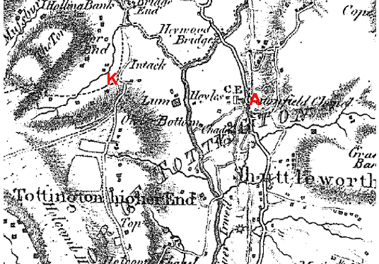
Observations |  | The River Irwell and River Ogden are shown and meet in a 'v' shape just north of Irwell Vale. Irwell Vale is not shown on the map although Lumb (Lum) is shown to the south. Blackburn Road and Helmshore Road are shown. A church is shown on Burnley Road in proximity to point A and just south of 'Intack' on Helmshore Road are two buildings and a way extending east from Helmshore Road which may be part of the Route from point K.
Investigating Officer's Comments |  | The Route is not shown, with the possible exception of a short section east from point K, suggesting that it did not exist as a through route which is consistent with Irwell Vale not existing at that time.
Honour of Clitheroe Map | 1804 | A privately produced map of land owned by the Honour of Clitheroe – Henry Duke of Buccleuth and Elizabeth Duchess of Buccleuth. It specifically shows boundaries of coal leases granted by them. 'Roads' were identified in the key but there was no apparent distinction between those which may have been considered to be public or private.
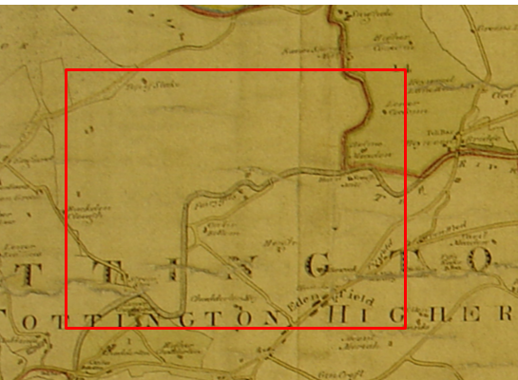
Observations |  | The Honor of Clitheroe map shows the area but the Route is not shown and Irwell Vale is not shown. Unlike more conventional maps today, the map was not drawn with the north point at the top of the map making orientation and interpretation of the map more difficult. (the top of this map is roughly north west)
Investigating Officer's Comments |  | The Route probably did not exist in the early 1800s.
Greenwood’s Map of Lancashire | 1818 | Small scale commercial map. In contrast to other map makers of the era Greenwood stated in the legend that this map showed private as well as public roads.
Observations |  | Irwell Vale and the Route is not shown.
Investigating Officer's Comments |  | The Route probably didn't exist in 1818 as Greenwood was known to show both public and private vehicular roads – or, at that time, was not considered by the Surveyor, to be of substantial nature and was therefore not shown on the map.
Stockdale's Map of Lancashire | 1818 | Small scale commercial map published in the same year as Greenwood's Map detailed above.
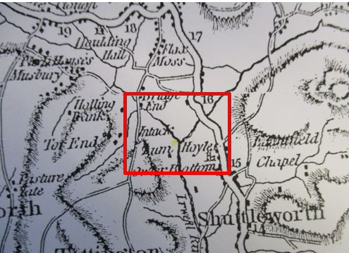
Observations |  | The Route is not shown and Irwell Vale is not shown or named on the map.
Investigating Officer's Comments |  | The Route probably did not exist in 1818.
Hennet's Map of Lancashire | 1830 | Small scale commercial map. In 1830 Henry Teesdale of London published George Hennet's Map of Lancashire surveyed in 1828-1829 at a scale of 71/2 inches to 1 mile. Hennet's finer hachuring was no more successful than Greenwood's in portraying Lancashire's hills and valleys but his mapping of the county's communications network was generally considered to be the clearest and most helpful that had yet been achieved.
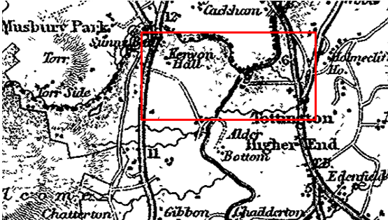
Observations |  | The Route is not shown. A way is shown from Blackburn Road north of a church (marked by a cross) extending in a straight line west towards the River Irwell which does not follow the alignment of Church Lane or Hardsough Lane but is shown located within the area concerned. Irwell Vale is not named on the map. West of the River Irwell a way is shown south of Kenyon Hall to Lumb (not named on the map) which is further south than the Route.
Investigating Officer's Comments |  | The Route probably did not exist in 1830 which is consistent with Irwell Vale not existing at that time.
Canal and Railway Acts | 1844 | Canals and railways were the vital infrastructure for a modernising economy and hence, like motorways and high speed rail links today, legislation enabled these to be built by compulsion where agreement couldn't be reached. It was important to get the details right by making provision for any public rights of way to avoid objections but not to provide expensive crossings unless they really were public rights of way. This information is also often available for proposed canals and railways which were never built.
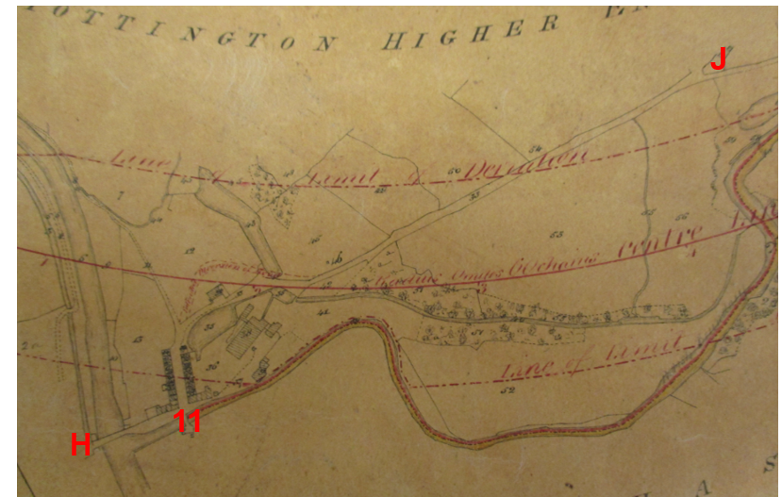
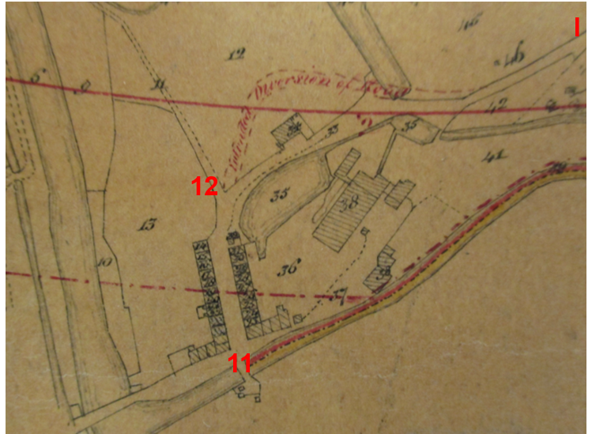
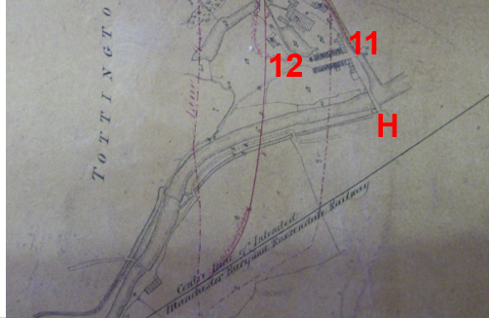
Observations |  | A search of the railway records deposited in the County Records Office was made. Limited records relating to the two railways that cross the Route were available.  The Parliamentary Deposited Railway plans for the proposed railway from Tottington Higher End to Accrington dated 1844 shows the intended course of the railway that passes through the area of Irwell Vale. The plan identifies the proposed railway on a line south east of point H but does not show the Route and it does not appear that it would be affected by the intended railway.  The plan available to view shows the Route passing through Irwell Vale from point H through to point J. It appears that it was intended that part of the Route between point 12 and point I was to be diverted and an alternative road is shown marked red and labelled "Intended Diversion of Road".  Plots of land and the Route are numbered on the plan but there is no book of reference available to provide any information about the numbered plots.
Investigating Officer's Comments |  | The Route existed between points H-11-12 in 1844. Between points 12-J a way is shown which was subsequently realigned by the construction of the railway which is crossed by the Route at point 13. The proposed diversion shown on the plan close to point J was never implemented and it is not known whether the use of the term 'road' was intended to refer to any public rights.
Tithe Map and Tithe Award or Apportionment | 1838 | Maps and other documents were produced under the Tithe Commutation Act of 1836 to record land capable of producing a crop and what each landowner should pay in lieu of tithes to the church. The maps are usually detailed large scale maps of a parish and while they were not produced specifically to show roads or public rights of way, the maps do show roads quite accurately and can provide useful supporting evidence (in conjunction with the written tithe award) and additional information from which the status of ways may be inferred.
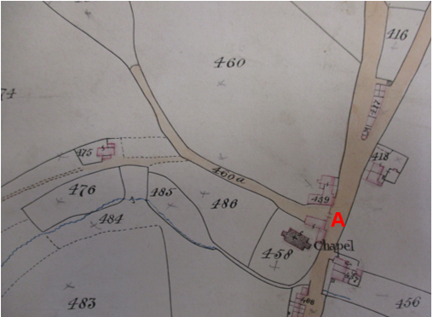
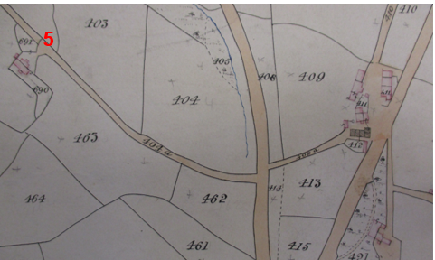
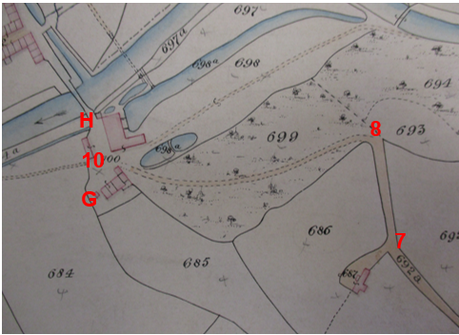
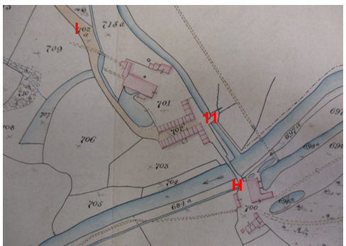
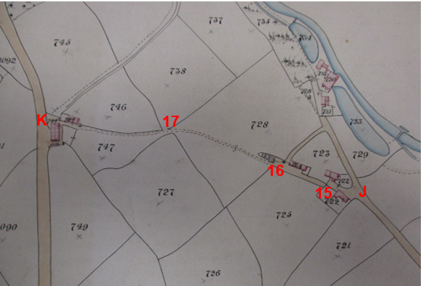
Observations |  | The Tottington Higher End Tithe Map of 1838 was inspected in the County Records Office.  From point A the Route is shown as a bounded and shaded track numbered 460a which appears to be open – but possibly restricted in width at point A and extends in a general north westerly direction to provide access to a pasture field recorded as being called 'long shut' with a further track shown to leave the Route to provide access to a property. The Tithe Award described hereditament 460a as a 'Lane' owned by Samuel Ashton and occupied by James Jackson for which no tithe was payable. 'Long shut' was also recorded as being owned and occupied by Samuel Ashton and James Jackson.  The Route from point D (not marked on the insert) to point 5 is shown on the Tithe Map as part of a longer bounded way which extends west from Blackburn Road. It is numbered 404a and described as a 'lane' owned by John Bowker and occupied by William Sagar for which no tithe was payable. At point 5 the Route provides access to a property and immediately beyond point 5 a line is shown across the Route which may indicate the existence of a gate.  The Route is then shown to continue as a bounded track providing access to a further property at point 7 and continuing to point 8. It is numbered on the map as plot 692a and described as a 'lane' owned by John Bowker and occupied by William Sagar for which no tithe was payable.  From point 8 the Route is shown to turn sharply and continue in a more westerly direction as a shaded but unbounded track through plot 699 which is described in the Award as woodland for which no tithes are listed and which was owned by John Bowker and occupied by William Sagar.  The Route continues through point 10 where it passes between buildings and then turns to continue in a more northerly direction to point H crossing an open unshaded area numbered as plot 700 which is described in the Award as 'Mills' owned by John Bowker and occupied by William Sagar.  Beyond point H the Route is shown crossing the River Irwell via unnamed bridge and continuing in a north-north westerly direction to point 11. This part of the Route is unshaded and unnumbered but is bounded on either side. It appears to form part of plot 700 which is described in the Award as 'Mills' owned by John Bowker and occupied by William Sagar.  From point 11 the Route is shown passing between two rows of houses and is shaded and numbered as plot 702 which is described in the Award as 'Cottages and Road' owned by John Bowker and occupied by Stott and Aitken. The Route continues as a bounded and shaded 'road' numbered as part of plot 702a and described in the Award as a road from plot 703 (the plot of land to the south of point 12 on the Committee plan) to plot 731 (a point on Haslingden Footpath 386 at Raven Shore beyond the junction of the Route at point J). The 'road' is listed as being privately owned by John Bowker and occupied by William Barker.  From point J the Route is shown passing between two properties both numbered as plot 722 described as 'Buildings, fold and garden' owned by John Bowker and occupied by Thomas Elton. It is not possible to see whether access from plot 722 along the Route west towards Iron Gate was available through point 15 as there is a line across the Route and the continuation of the track is shown at an offset angle. Access to the building numbered as plot 724 appears to be from a track to the north.  From point 15 to point 16 the Route is shown as a bounded and shaded track but not numbered. From point 16 it is shown as a shaded but unbounded track across plot 728 which is described in the Award as 'Middle Shore Meadow' owned by John Bowker and occupied by William Barker. The Route appears to pass unrestricted through point 17 and then continues as a track along the edge of the northern boundary of plot 747, again owned by John Bowker but occupied by Richard Rothwell, to pass between buildings numbered as plot 748 and described as 'Farm, house and barn' owned by John Bowker and occupied by Richard Rothwell. There does not appear to be any open access (there might have been a gate) from the Route onto Helmshore Road at point K although there does appear to be open access south of point K along the side and to the rear of the buildings.
Investigating Officer's Comments |  | From consideration of the information available in the Tithe Award and Map it is considered unlikely that the Route existed as a public bridleway or public carriageway in 1838.  The shading of the Route – or parts of it – is not considered to be significant other than suggesting that those parts of the Route existed as substantial physical features that could be identified as tracks on the ground.  The Award lists a number of roads at the end of the schedule as 'Road a, Road b, Township road c, and turnpike roads' all of which are labelled on the map and which correspond to ways now recorded as the main public vehicular highways through the former township. No part of the Route is listed in such a way suggesting that it was not considered to be a public vehicular highway at that time.  The majority of the Route (with the exception of the section between point A via point 2 to point D, which only came into existence in the 1960s at the earliest) is shown to physically exist across land owned by John Bowker and was listed as being used and occupied for a number of different purposes.  It appears that access may have been possible along the Route from Blackburn Road to point D and then from point D through to point J and on to point 15 at which point it is less clear whether access would have been available and if so whether it was on exactly the same line as the Route. From point 15 to point 16 a route is shown to exist although ugh from point J to point K and if a way did exist, it appears that it may have varied slightly from the Route in existence today.  The fact that all the land (with the exception of the section between point A and point 2) crossed by the Route was in the same ownership, and the fact that different occupiers and land uses listed, with the Route not considered as a separate entity, is consistent with the a private carriageway to access different parts of land owned by a single individual.
Inclosure Act Award and Maps |  | Inclosure Awards are legal documents made under private acts of Parliament or general acts (post 1801) for reforming medieval farming practices, and also enabled new rights of way layouts in a parish to be made. They can provide conclusive evidence of status.
Observations |  | There is no Inclosure Award for the area over which the Route is found.
Investigating Officer's Comments |  | No inference can be drawn.
Cassini Map, Old Series, Sheet 109 Manchester and 103 Blackburn and Burnley | 1842-44 and 1842-1859 | Reproduction extract of Map Sheets 103 and 109. Originally published between 1842 and 1859. The Cassini publishing company produced maps based on Ordnance Survey maps. These early maps have been more recently enlarged and reproduced to match the modern day 1:50k OS Landranger Maps and are readily available to purchase.
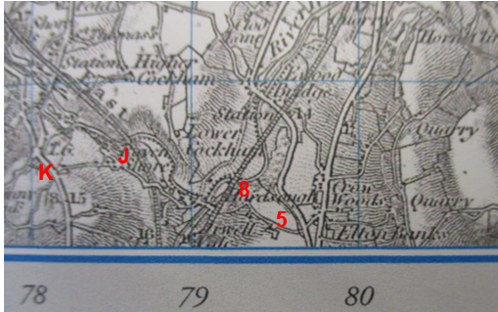
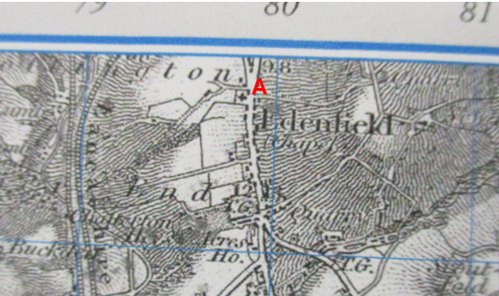
Observations |  | The start of the Route from point A is shown as part of a longer way providing access to a property and land.  The Route from Blackburn Road, passing through point 5 and the distinctive corner at point 8 can be clearly seen crossing the railway and then continuing west across the River Irwell and through Irwell Vale (not named on the map). The Route is clearly shown continuing via point J to point K.
Investigating Officer's Comments |  | These maps were believed to have been based on post 1840 Ordnance surveys – the same surveys which would have been used to compile the first edition 6 inch maps.  The original scale of the map (1 inch to the mile) means that only the more significant roads are generally shown. The reason that these maps were published by independent companies in the 1800s would probably have been to assist the increasing numbers of travelling public and so the way in which the Route is clearly shown (from point D to point K) suggested not only that it existed but that it was capable of being used by the public in the mid 1800s.
6 Inch Ordnance Survey (OS) Map | 1850 | The earliest Ordnance Survey 6 inch map for this area surveyed in 1844-47 and published in 1850.
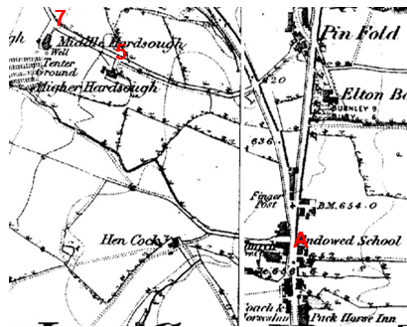
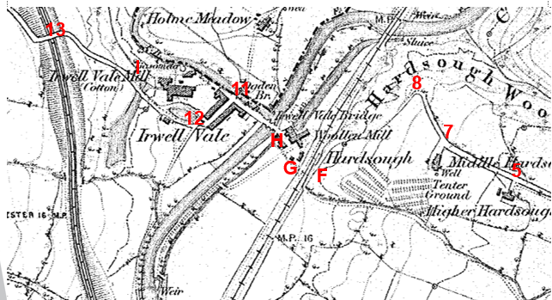
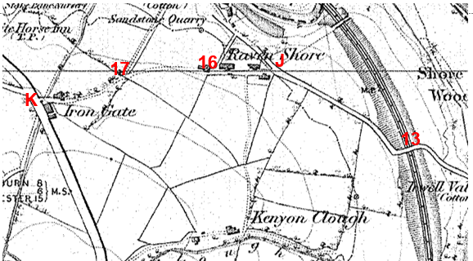
Observations |  | The Route is shown from point A as a wide bounded way extending west as a bounded way providing access to an open field with a further way branching off in a south west direction to Hen Cocks.  Further north, on Blackburn Road, a bounded way is shown extending in a westerly direction directly opposite the access up to Pinfold. It provides access to properties labelled as Hardsough and Middle Hardsough (points 5 and 7) and continues as a bounded track to point 8. Beyond point 8 a less defined way continues in a south westerly direction to point F where it meets the railway.  There is no crossing of the railway indicated on the plan although the scale of the map may mean that this was not shown. From point G a single dashed line can be seen suggesting that there may have been a railway crossing. Since the tenter ground (an area used for drying newly manufactured cloth) was on the opposite side of the railway from the mills it is almost certain that there was a crossing to transport the cloth for drying and back.  Between point G and point H a way consistent with the Route appears to exist past some buildings and directly to the south of a woollen mill. The bridge across the River Irwell is shown and named and beyond it there are a number of further buildings collectively labelled as Irwell Vale. With the Route through Irwell Vale clearly visible through to point I.  Beyond point I the Route is shown as a bounded track crossing a further railway at point 13 and continuing as a bounded track to point J. It then continues as an unbounded track through Raven Shore and in a generally westerly direction as an unbounded track across open fields to Iron Gate where it exits onto Helmshore Road.
Investigating Officer's Comments |  | It appears that since the production of the earlier commercial maps examined there has been a significant amount of development in the valley. The railway had been constructed east of the River Irwell and a further railway constructed west of Irwell Vale. The hamlet of Irwell Vale has been largely constructed with a woollen mill on the east of the River Irwell and a cotton mill to the west. The principal access roads to the hamlet are clear and the Route is clearly shown passing through the hamlet and providing access to public carriageways to the east (Blackburn Road) and the west (Helmshore Road) suggesting not only that it existed but that it was capable of being used by the public in the mid-1800s.
25 Inch OS Map | 1893 | The earliest OS map at a scale of 25 inch to the mile. Surveyed in 1891 and published in 1893.
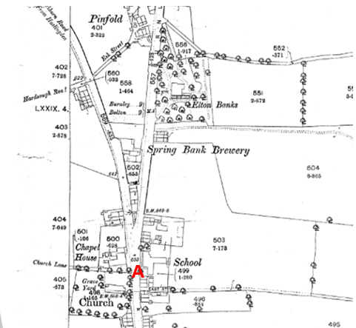
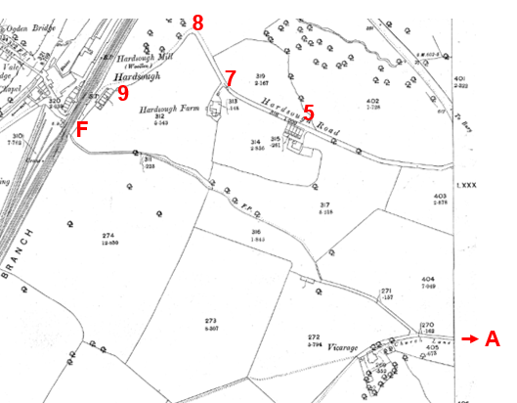
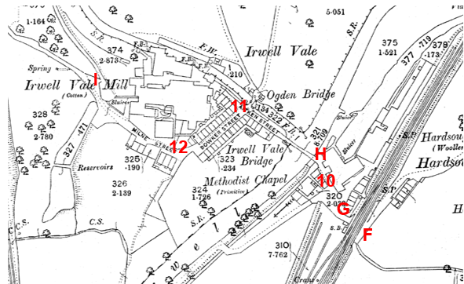
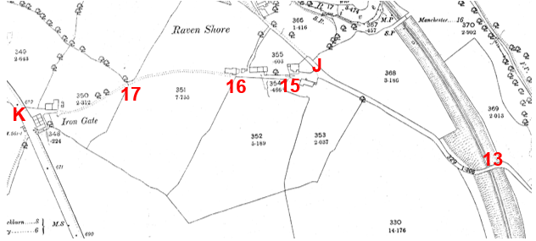
Observations |  | The Route from point A is clearly shown and is named on the map as Church Lane providing access from Blackburn Road, adjacent to the church to the vicarage and to farmland.  The Route from point D is also shown as part of a road starting on Blackburn Road and named on the map as Hardsough Road providing access to a number of unnamed properties from point 5, Hardsough Farm from point 7 and some buildings immediately east of the railway at 'Hardsough' (point 9).  The railway crossing is not marked but the Route continues from point 9 past the buildings to point F and then continues west from point G. A signal box (SB) is marked adjacent to point G. Beyond point G the Route is shown passing the mill, through point 10 to point H. It then crosses the River Irwell via Irwell Vale Bridge (named). The Route then continues along Aitken Street to point 11 and then along Bowker Street and Milne Street to point I. From point I the Route follows a bounded track crossing the railway via a bridge at point 13 to point J.  From point J to K a Route is shown on the map through Raven Shore to exit onto Helmshore Road at Iron Gate (point K). It passes between buildings and appears to be gated at points 15 and 16 and then continues as an open track across fields passing through a field boundary at point 17 to exit onto Helmshore Road at Iron Gate. A solid line is shown across the Route at point K suggesting that access may have been gated or may have been to the south of the buildings.
Investigating Officer's Comments |  | Access appears to have been available along the Route from point A to point 2 providing access to the vicarage and access to some fields (from which a footpath (f.p) is shown to extend although this does not connect to the rest of the Route as it did when the A56 was built.  Access along the Route from point D through Irwell Vale appears to be available and appears to be wide enough to be used on horseback or vehicles at that time.  Access from Irwell Vale along the Route to point J and onwards to Helmshore Road at point K also appears to be available.
Quarter Sessions Diversion Order | 1894 | Diversion of a highway from Ewood Bridge to Irwell Vale under Section 84 Highways Act 1835.
Observations |  | A Quarter Sessions Order made at Preston Magistrates Court in 1894 has also been considered. The Quarter Sessions Order was to allow the building of the sewage works by the Haslingden, Rawtenstall and Bacup Outfall Sewerage Board and the new access is now the Irwell Vale Road (U 60134). The Order diverted an 'old highway' leading from Ewood Bridge to the north side of the Ogden Bridge near to point 11 and the section to be diverted is described as commencing at Ewood Bridge 'to a road leading from Irwell Vale to Ravenshore and running thence in a southerly direction along such road to the place where the highway here fore used enters Irwell Vale'. The route to be diverted is described in the Order as being a public footway and that a toll was payable in respect of all horses cattle carts or carriages passing over the said old highway. It was stated that the new highway to be constructed was to be wider so as to be more commodious to the public and that no toll would be charged for any horses cattle carts or carriages passing over the new proposed new highway which will be a public highway for all purposes’.
Investigating Officer's Comments |  | The Order does not directly relate to the Route. However, it provides evidence that a way not shown to exist on the early commercial maps and apparently predating the development of Irwell Vale was considered to be a public footpath (footway) but that horse and mechanically propelled vehicles in existence at that time were originally required to pay a toll to use it. It may be the case that the other ways which came into being to provide access to the mills and hamlet were also considered to be private or ‘Public Footway’ only and that any higher status users may have had to pay a toll. On the other hand it could be that horses and vehicles were subject to a toll on this road which avoided the steep gradients on what might have been the public roads via Hardsough Lane to Edenfield or westwards up to Iron Gate (the Route). We cannot draw further inference from this Order regarding which of these was the situation.
25 inch OS Map | 1911 | Further edition of the 25 inch map surveyed in 1891, revised in 1908 and published in 1911.
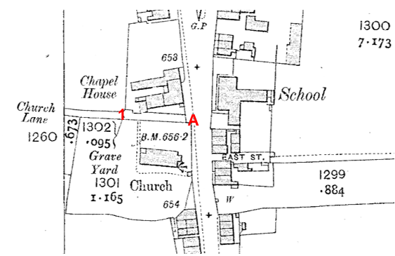
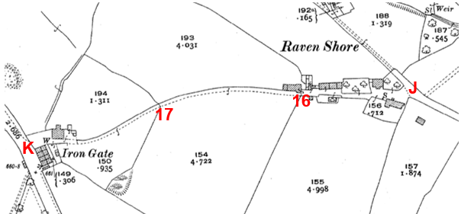
Observations |  | The full length of the Route under investigation is shown (with the exception of the section between points 2-B-C-D-E which were only created as part of the construction of the A56).  A line is shown across the junction of the Route with Blackburn Road suggesting the possible existence of a gate.  The Route appears to be accessible from Raven Shore at point J through to Helmshore Road at point K but appears gated at point 16 and 17. Access onto Helmshore Road may have been available at point K but the existence of a solid line across the end of the Route is suggestive of a gate or access may have been restricted to the southern end of the buildings south of point K.
Investigating Officer's Comments |  | The Route under investigation appears to be wide enough to have been used on horseback in the early 1900s although the section from point A to point 2 (and beyond) does not appear to offer a through Route – but provides access to the vicarage and some agricultural land and Route labelled as a footpath.
Finance Act 1910 Map | 1910 | The comprehensive survey carried out for the Finance Act 1910, later repealed, was for the purposes of land valuation not recording public rights of way but can often provide very good evidence. Making a false claim for a deduction was an offence although a deduction did not have to be claimed so although there was a financial incentive a public right of way did not have to be admitted.  Maps, valuation books and field books produced under the requirements of the 1910 Finance Act have been examined. The Act required all land in private ownership to be recorded so that it could be valued and the owner taxed on any incremental value if the land was subsequently sold. The maps show land divided into parcels on which tax was levied, and accompanying valuation books provide details of the value of each parcel of land, along with the name of the owner and tenant (where applicable).  An owner of land could claim a reduction in tax if his land was crossed by a public right of way and this can be found in the relevant valuation book. However, the exact route of the right of way was not recorded in the book or on the accompanying map. Where only one path was shown by the Ordnance Survey through the landholding, it is likely that the path shown is the one referred to, but we cannot be certain. In the case where many paths are shown, it is not possible to know which path or paths the valuation book entry refers to. It should also be noted that if no reduction was claimed this does not necessarily mean that no right of way existed.
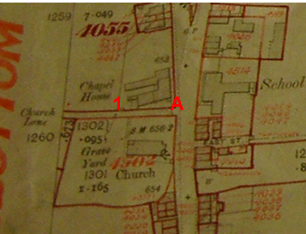
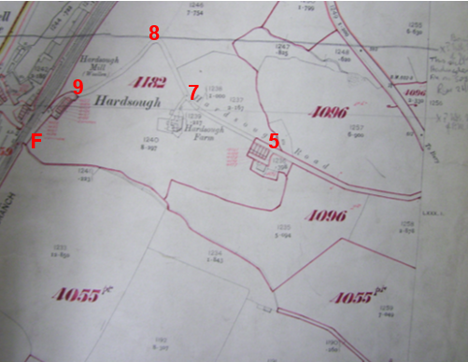
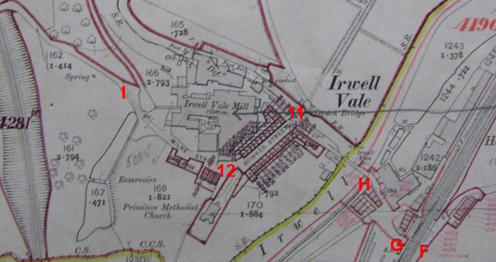
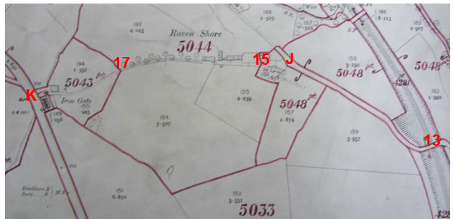
Observations |  | There are no Finance Act records available to view in the County Records Office. Copy extracts of the Finance Act Maps and relevant field book entries were obtained from The National Archives.  The Finance Act maps show the Route from point A as excluded from the adjacent numbered hereditaments. The excluded road splits west of point 2 with one part terminating at the vicarage and the other terminating at the access into an open field which forms part of hereditament 4055 on the plan.  Between point D to just north west of point 5 (adjacent to the end of the row of terraced houses) the Route, known as Hardsough Road, is also excluded from the numbered hereditaments and hereditament 4096 is shown split by the Route.  Beyond the end of the terrace houses (north west of point 5) to point 9 the Route is contained within hereditament 4182 which is listed as being owned and occupied by George Barker and described as houses, buildings and land. A £35 deduction has been made for 'footpaths' but the exact route/s for which the deduction is claimed is not specified.  The next section of the Route – from point 9 past the terraced houses, over the railway to point G is not excluded from the hereditaments but is contained within plot 1559 and which includes the railway line.  Beyond point G the Route appears to be included within a very large hereditament numbered 5085 including the Route up to the railway bridge at point 13. This land is described in the Field Book as being situated in Irwell Vale and is described as 'Mill' owned and occupied by Thomas Aitken and Son. No deductions are listed for public rights of way or user. From the eastern side of the railway bridge at point 13 the Route is then shown excluded from the numbered hereditaments as far as point J. Land on either side of the excluded section is braced and numbered 5048 with the Route from point J to point 15 included within hereditament 5048 which is listed as being land, building and cottage at 'Shore' owned by John Arthur Witham of Foldhouse, Helmshore and occupied by Henry Hindle. No deduction is claimed for public right of way or user.  From point 15 the Route then passes into hereditament 5044 through to point 17. The plot is described as 'Ravenshore, land, buildings and cottage' and is listed in the copyhold ownership and occupied by Fanny Sparrow. No deductions are listed for public rights of way or user.  From point 17 through to the end of the Route at point K the rest of the Route is included within part of hereditament 5043. The plot is described as land and buildings at Irongate, Helmshore including cottages and land. It is listed as being occupied by Ashworth Whittacker and owned by Powitt and Sons. A £14 deduction is listed for a right of way for owners of shore farm (easement) and a £7 deduction for footpaths. The location of the footpath(s) is unspecified and the plot is split by Helmshore Road and consists of a further field through which there is a way now recorded as a public footpath.
Investigating Officer's Comments |  | On balance it is considered that the Finance Act information does not support the existence of a public bridleway in 1910.  It is normal to see an acknowledged public vehicular highway excluded from the numbered hereditaments as part of the process of compiling the taxation records and for ways considered to be public footpaths or bridleways at that time to be included in the numbered hereditaments for which a deduction is claimed.  The maps showed land in private ownership and, by implication, land not regarded as being sufficiently private to be taxable (i.e.) included within numbered plots is good evidence, but not conclusive, of public carriageway rights.  That part of Route between point A and point 2 was excluded from the numbered hereditaments suggesting that at the time it may have been considered to carry public carriageway/vehicular rights.  The Route known as Hardsough Road appears to have been considered differently with the section from point D to just past point 5 excluded from the numbered hereditaments and the section down to the houses adjacent to the railway (point 9) included in a numbered plot.  The Route through Irwell Vale is not excluded from the numbered hereditaments and no deductions have been claimed for public rights of way or user suggesting that the owner of the hamlet at that time considered the Routes through it as being private at that time or did not wish to admit public rights.  From point 13 to point J the Route is shown excluded from the numbered hereditaments which may suggest some acknowledgement of public rights. However, the Route from point J to point K passes through 3 different numbered plots for which no deductions have been claimed for the existence of a public bridleway and although a deduction is claimed for a public footpath in hereditament 5043 it is not known whether the deduction relates to the Route under investigation and it does not specify a deduction for equestrian use.
25 Inch OS Map | 1929 | Further edition of 25 inch map, surveyed 1891, revised in 1927 and published in 1929.
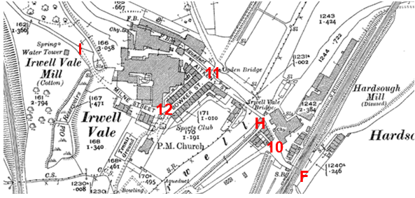
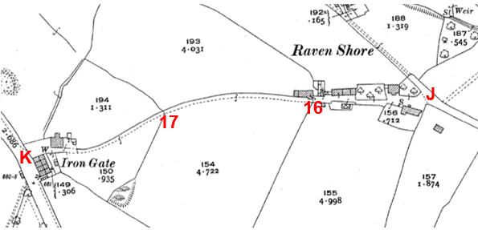
Observations |  | The Route is shown largely unaltered from the earlier edition of the 25 inch map. The Route between point J and point K now appears to be enclosed on one side.
Investigating Officer's Comments |  | The Route appeared to be wide enough to be used by horses in the 1820s.
Bartholomew's half inch to the mile Sheet 8 – Liverpool & Manchester | 1904 and 1920 | The publication of Bartholomew's half inch maps for England and Wales began in 1897 and continued with periodic revisions until 1975. The maps were very popular with the public and sold in their millions, due largely to their accurate road classification and the use of layer colouring to depict contours. The maps were produced primarily for the purpose of driving and cycling and the firm was in competition with the Ordnance Survey, from whose maps Bartholomew's were reduced. An unpublished Ordnance Survey report dated 1914 acknowledged that the road classification on the OS small scale map was inferior to Bartholomew at that time for the use of motorists.
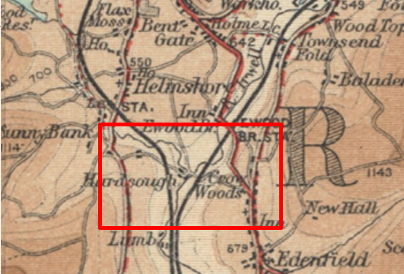
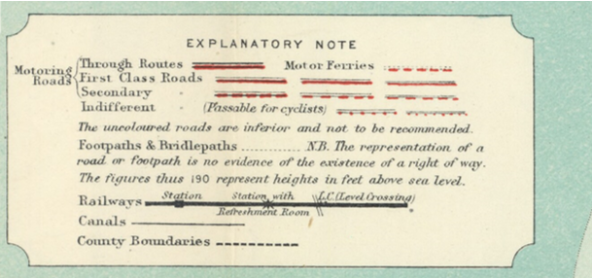
Observations |  | The Route from point A through point 1 and onwards is not shown.  Hardsough Road (passing through point D) is shown crossing the railway and the river and passing through Irwell Vale (not named). It can then be seen continuing to cross the second railway and continue up to Raven Shore and through to Helmshore Road. It is shown as an uncoloured road and described as being inferior and not to be recommended.
Investigating Officer's Comments |  | The early 1900s saw a significant increase in the use of motorised vehicles and the classification of minor roads was constantly being revised by Bartholomew as some were improved to cope with the increasing traffic while others were virtually abandoned and fell into disrepair. Before 1920, few roads other than main roads were tarred but the travelling public had lower expectations of surface conditions than today and it would not be uncommon for an unsealed road, at the time considered adequate for horse drawn vehicles, to be shown.  The Route (with the exception of the Route between point A-2-B-C-D-E) is shown on the map supporting the view that it physically existed in the 1920s. However, it did not appear to be considered to be a public vehicular highway or passable for cyclists at that time.
Authentic Map Directory of South Lancashire by Geographia | Circa1934 | An independently produced A-Z atlas of Central and South Lancashire published to meet the demand for such a large-scale, detailed street map in the area. The Atlas consisted of a large scale coloured street plan of South Lancashire and included a complete index to streets which includes every 'thoroughfare' named on the map.  The introduction to the atlas states that the publishers gratefully acknowledge the assistance of the various municipal and district surveyors who helped incorporate all new street and trunk roads. The scale selected had enabled them to name 'all but the small, less-important thoroughfares'.
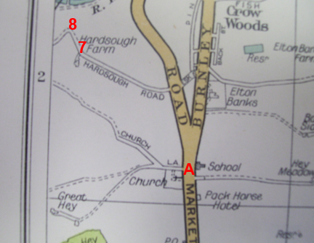
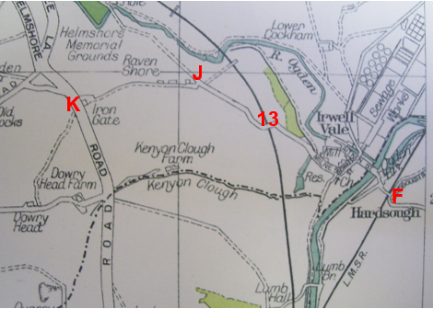
Observations |  | The Route from point A to point 2 is shown and identified as part of Church Lane.  The Route from point D (on Hardsough Road) is shown to point F and across the railway, through Irwell Vale and on to Raven Shore at point J. Between point J and point K the Route is shown as mainly being unenclosed on the south side. Church Lane, Hardsough Road, Aitken Street, Bowker Street and Milne Street are all named on the map.
Investigating Officer's Comments |  | The Route (with the exception of the sections created following the construction of the A56) are shown in an atlas consistent with other ways proven or suspected of carrying public vehicular rights.
Aerial Photograph | 1940s | The earliest set of aerial photographs available was taken just after the Second World War in the 1940s and can be viewed on GIS. The clarity is generally very variable.
Observations |  | The photograph shows the full length of Route prior to the construction of A56. Hardsough Road is very clearly defined suggesting that it was a substantial Route actually being used by horses and vehicles at that time. The Route between point J and point K is visible but quite faint suggesting less significant levels of use more consistent with pedestrian and possibly equestrian use. It was not possible to see in sufficient detail whether there were any gates or other types of restrictions across the Route.
Investigating Officer's Comments |  | The Route (pre-construction of the A56) existed on the ground and appeared to be wide enough to be used on horseback.
1:2500 OS Map | 1963 | Further edition of OS map reconstituted from former County Series and revised in 1961 and published 1963 as National Grid Series.
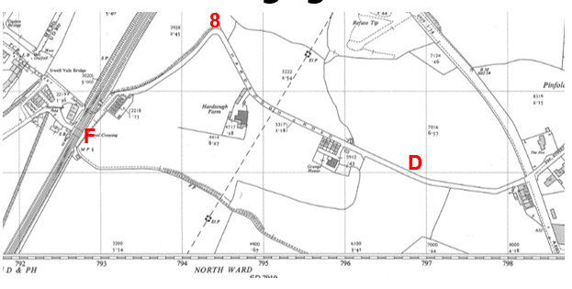
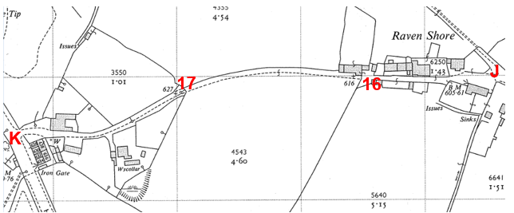
Observations |  | The map shows the Route existed on the ground. Gates may have existed across the Route at points J, 16 and 17.  The A56 is not shown on the map.
Investigating Officer's Comments |  | The map was revised in 1961 prior to the construction of the A56. The Route from point D passing through Irwell Vale to point K appears to be accessible but the status is not indicated.
6 Inch OS Map | 1965 | OS map published in 1965 at a scale of 6 inches to 1 mile (1:10,560) and revised in 1961.
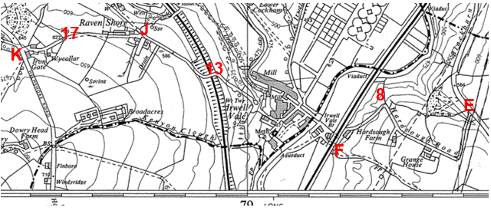
Observations |  | The map shows the Route in the same way as the 1:2500 OS map detailed above. The A56 is not shown on the map but its existence has been hand-drawn onto the map together with the Route between point D and point E.
Investigating Officer's Comments |  | The map was revised in 1961 prior to the construction of the A56. The Route under investigation from point D passing through Irwell Vale to point K appears to have been accessible to horses and possibly vehicles. The hand-drawn annotations are undated so no inference can be drawn regarding the date of construction, status or accessibility.
Aerial photograph | 1960s | The black and white aerial photograph taken in the 1960s and available to view on GIS.
Observations |  | The whole length of the Route (pre the construction of the A56) is clearly visible although the scale of the photograph makes it impossible to determine whether any gates or other restrictions existed across it.
Investigating Officer's Comments |  | The Route (pre-A56) appeared capable of being used.
1:2500 OS Map | 1971 | Further edition of OS map reconstituted from former County Series and revised in July 1970and published 1971 as National Grid Series.
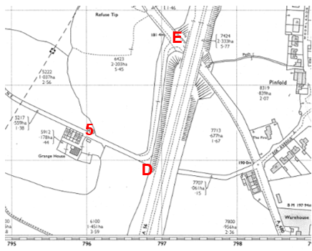
Observations |  | The 1971 revision shows the construction of the A56 and the Route between point D and point E. It does not show the Route extending south west from point D towards point C. The Route between point D and point 9 remains unaltered from earlier maps but is labelled as 'Hardsough Lane' rather than 'Hardsough Road'. The level crossing is marked at point F and the railway crossed by the Route at point 13 is marked as being 'disused'. Gates appear to exist across the Route at point 16 and point 17.
Investigating Officer's Comments |  | The Route existed on the ground between point D and point E by 1971 and appeared capable of being used. The Route between point C and point D may not have physically existed at that time.
1:2500 OS Map | 1985 | Further edition of OS map reconstituted from former County Series and revised in 1983 and published 1985 as National Grid Series.
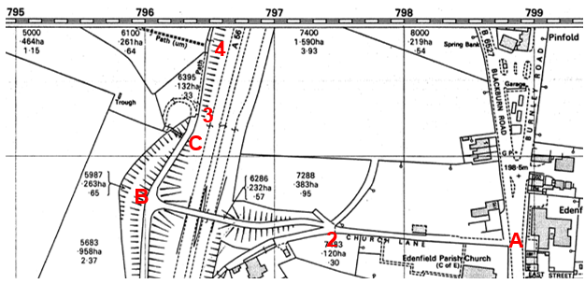
Observations |  | The Route legally created by the construction of the A56 is shown from point 2 crossing the A56 via a substantial bridge and continuing from point B as a bounded track to point C. Lines are shown across the Route at point 3 and point 4 which may indicate the existence of gates, stiles or some other form of barrier.
Investigating Officer's Comments |  | The 1983 map sheet available to view confirms the physical existence of the Route between point 2 – point B – point C and the Route appeared to continue towards point D (labelled as 'path'). It is not possible to determine from the map whether the Route would have been accessible to horses in 1985.
Aerial Photograph | 2000 | Aerial photograph available to view on GIS.
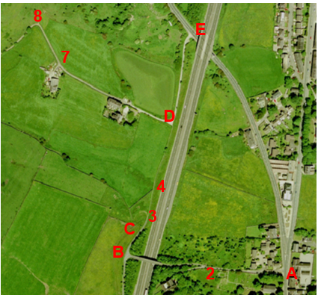
Observations |  | The whole length of the Route could be seen on the 2000 aerial photograph.
Investigating Officer's Comments |  | The Route existed and appeared to be capable of being used on horseback. The existence of any gates, stiles or other limitations which may have prevented or restricted access could not, however, be seen due to the scale of the photographs.
Definitive Map Records |  | The National Parks and Access to the Countryside Act 1949 required the County Council to prepare a Definitive Map and Statement of Public Rights of Way.  Records were searched in the Lancashire Records Office to find any correspondence concerning the preparation of the Definitive Map in the early 1950s.
Parish Survey Map | 1950-1952 | The initial survey of public rights of way was carried out by the parish council in those areas formerly comprising a rural district council area and by an urban district or municipal borough council in their respective areas. Following completion of the survey the maps and schedules were submitted to the County Council. In the case of municipal boroughs and urban districts the map and schedule produced, was used, without alteration, as the Draft Map and Statement. In the case of parish council survey maps, the information contained therein was reproduced by the County Council on maps covering the whole of a rural district council area. Survey cards, often containing considerable detail exist for most parishes but not for unparished areas.
Observations |  | The Route under investigation is within Ramsbottom which was a former urban district in the 1950s and Haslingden, a former municipal borough so parish survey maps were not compiled.
Draft Map |  | Maps and statements were prepared for Ramsbottom and Haslingden by the district and municipal borough councils and used by the County Council as the Draft Maps for those areas.  The Draft Maps were given a “relevant date” (1st January 1953) and notice was published that the draft map for Lancashire had been prepared. The draft map was placed on deposit for a minimum period of 4 months on 1st January 1955 for the public, including landowners, to inspect them and report any omissions or other mistakes. Hearings were held into these objections, and recommendations made to accept or reject them on the evidence presented.
Observations |  | The majority of the Route was recorded as public footpath on the Draft Maps with the exception of the Route through Irwell Vale between points F-G and points H-I which were not recorded on the maps.  The Route between points 2 – B – C – D – E did not exist at the time that the Definitive Map was originally prepared.
Provisional Map |  | Once all representations relating to the publication of the draft map were resolved, the amended Draft Map became the Provisional Map which was published in 1960, and was available for 28 days for inspection. At this stage, only landowners, lessees and tenants could apply for amendments to the map, but the public could not. Objections by this stage had to be made to the Crown Court.
Observations |  | The Route was shown in the same way on the Provisional Map as on the Draft Map and no representations were made to the County Council.
The First Definitive Map and Statement |  | The Provisional Map, as amended, was published as the Definitive Map in 1962.
Observations |  | The Route was shown in the same way on the First Definitive Map as on the Draft Map and Provisional Maps.
Revised Definitive Map of Public Rights of Way (First Review) |  | Legislation required that the Definitive Map be reviewed, and legal changes such as diversion orders, extinguishment orders and creation orders be incorporated into a Definitive Map First Review. On 25th April 1975 (except in small areas of the County) the Revised Definitive Map of Public Rights of Way (First Review) was published with a relevant date of 1st September 1966. No further reviews of the Definitive Map have been carried out. However, since the coming into operation of the Wildlife and Countryside Act 1981, the Definitive Map has been subject to a continuous review process.
Observations |  | When the Map and Statement were reviewed the Route was shown in the same way as it had been shown on the First Definitive Map and did not show the legal changes that were made to the routes of Footpath 128 and 130 Ramsbottom as part of the construction of the A56 (detailed in a separate section of this report).
Investigating Officer's Comments |  | From 1953 through to 1975 there is no indication that the Route was considered to be of any higher status than public footpath by the Surveying Authority. There were no objections to the depiction of the status of the Route from the public when the maps were placed on deposit for inspection at any stage of the preparation of the Definitive Map.  The statements produced during the various stages of the Definitive Maps of Public Rights of Way provide no helpful information in determining the status of the Route. The Statement entries for Ramsbottom Footpaths 128, 130 and 131 are only recorded on the Draft and Provisional Statements and for an unknown reason are no longer included in the statements for the First Definitive or the Revised Definitive Map (First Review).
Highway Adoption Records including maps derived from the '1929 Handover Maps' | 1929 to present day | In 1929 the responsibility for district highways passed from district and borough councils to the County Council. For the purposes of the transfer, public highway 'handover' maps were drawn up to identify all of the public highways within the county. These were based on existing Ordnance Survey maps and edited to mark those ways that were public. However, they suffered from several flaws – most particularly, if a right of way was not surfaced it was often not recorded.  A right of way marked on the map is good evidence but many public highways that existed both before and after the handover are not marked. In addition, the handover maps did not have the benefit of any sort of public consultation or scrutiny which may have picked up mistakes or omissions.  The County Council is now required to maintain, under section 31 of the Highways Act 1980, an up to date List of Streets showing which 'streets' are maintained at the public's expense. Whether a road is maintainable at public expense or not does not determine whether it is a highway or not.
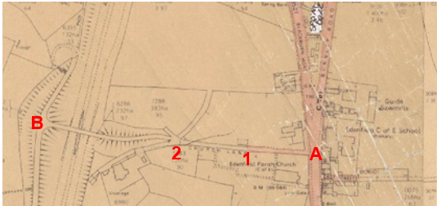
Route from point A
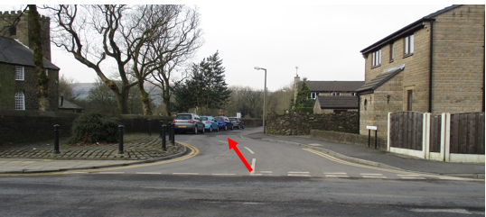
Route between point A and point 1
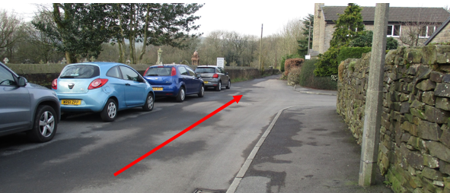
Observations |  | Only the section between point A and point 1 (Church Lane) is recorded as being publicly maintainable on the List of Streets by the County Council.  The photographs show the route as a tarmac road, with footway and street lights with a number of cars parked along it.
Investigating Officer's Comments |  | No inference can be drawn regarding public rights.
The Manchester – Burnley Trunk Road (Edenfield – Rawtenstall Level Crossing By-Pass) (Side Roads) Order 1964 | 1964 | Side Roads Order made by the Minister of Transport to carry out highway improvements and to stop up highways and construct new sections of highways in relation to the construction of the A56.
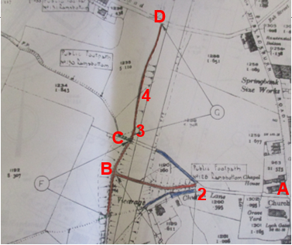
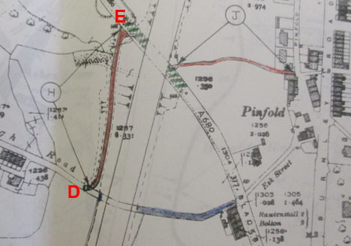
Observations |  | The eastern end of the Route was altered by the construction of the A56 in the 1960s.  The plan contained within the Order and details contained within Schedule 2 of the Order describes those highways to be stopped up with reference to the lettering and colouring on the plans. Highways to be stopped up were shown coloured blue and highways to be constructed shown coloured red. The Order states that new highways to be created will be footpaths unless otherwise stated in column 4 of the Schedule. The Route between points 2–B-C-D-E was created by the Order as public footpath.
Investigating Officer's Comments |  | The Route between point 2–B–C–D-E was legally created as public footpath by the Side Roads Order and was subsequently constructed in the mid 1960s.
Irwell Vale Bridge |  | LCC highway records were inspected with regards to the recording of Irwell Vale Bridge.
Observations |  | The date of construction is unknown but is believed to be in the early 1800s. The bridge was inspected by the County Council in 1989 and a detailed report produced. The report recorded that the bridge was owned and maintained by the Irwell Vale Estates (Lancaster) Ltd and recorded the Route across it as being an unadopted private road.
Investigating Officer's Comments |  | The records available make no reference to public use of the bridge.
Church Lane Bridge | 1964 - 1993 | LCC highway records were inspected with regards to Church Lane Bridge
Observations |  | A search was made of the Bridge records held by the County Council. The bridge constructed over the A56 and forming part of the Route (between point 2 and point B on the Committee plan) is recorded as 'Church Lane Bridge' owned by the Ministry of Transport and is described as carrying an occupation road. Plans within our records dated between 1964 and 1966 show the detail of the bridge to be constructed. Further plans dated 1993 related to the planned re-surfacing of the bridge.
Investigating Officer's Comments |  | The records available refer to the bridge as an occupation bridge and make no reference to public use. The exact date that the bridge was constructed is unknown but is unlikely to have been before 1966.
Statutory deposit and declaration made under section 31(6) Highways Act 1980 |  | The owner of land may at any time deposit with the County Council a map and statement indicating what (if any) ways over the land he admits to having been dedicated as highways. A statutory declaration may then be made by that landowner or by his successors in title within ten years from the date of the deposit (or within ten years from the date on which any previous declaration was last lodged) affording protection to a landowner against a claim being made for a public right of way on the basis of future use (always provided that there is no other evidence of an intention to dedicate a public right of way).  Depositing a map, statement and declaration does not take away any rights which have already been established through past use. However, depositing the documents will immediately fix a point at which any unacknowledged rights are brought into question. The onus will then be on anyone claiming that a right of way exists to demonstrate that it has already been established. Under deemed statutory dedication the 20 year period would thus be counted back from the date of the declaration (or from any earlier act that effectively brought the status of the route into question).
Observations |  | No Highways Act 1980 Section 31(6) deposits have been lodged with the County Council for the area over which the Route runs.
Investigating Officer's Comments |  | There is no indication by a landowner under this provision of non-intention to dedicate public rights of way over their land.
National Cycle Network Route 6 |  | Information regarding the inclusion of part of the Route as a nationally promoted cycleway.
Observations |  | The LCC Cycleway Officer was consulted who explained that part of the Route was proposed to be included as National Cycle Route 6 and is shown between point 6 and point J on both Sustrans http://www.sustrans.org.uk/ncn/map and OS Mapping as being part of National Cycle Route 6 with Sustrans providing Ordnance Survey with cycle route data.  He explains that temporary National Cycle Route stickers were erected on the Route in 2005 when there was an organised ride along Route 6 from London to Carlisle to celebrate 10 years of the National Cycle Route.  The Route out of Irwell Vale from point 6 to point J was included in a National Cycle Network Survey feasibility study of the proposed route in 1998. The report details the section from Helmshore Road to Irwell Vale describing the section of the Route between point 13 and point J as showing evidence of use by horses and recommending the provision of a mown strip to accommodate equestrian use.
Investigating Officer's Comments |  | Information from a study carried out in 2005 makes reference to evidence that the Route out of Irwell Vale to point J was being used by horses.

The affected land is not designated as access land under the Countryside and Rights of Way Act 2000 and is not registered common land.

Landownership

The list below indicates the landowners affected by this application.

- Starcrest Developments Limited, Lanmor House, 370/376 High Road, Wembley, Middx HA9 6AX.
- Barry Ernest Pitt and Susan Pitt, 2 Church Lane, Edenfield, Bury, Lancs, BL0 0QL
- Charles Edward Scrope Yorke and The Honourable
John Hotham Assheton care of Ingham and Yorke, Standen Estate Office,
Littlemoor, Clitheroe BB7 1HG and care of Napthens Solicitors, 7 Winckley Square, Preston PR1 3JD hold a caution again part of the land
- Secretary Of State For Transport of Great Minster House, 76 Marsham Street, London SW1P 4DR and care of Highways Agency, National Property Management and Disposals, Ash House, Falcon Road, Sowton, Exeter EX2 7LB
- Arnold Wilcox-Wood and Shirley Wilcox-Wood, Hardsough Farm, Hardsough Lane, Edenfield, Rossendale, Lancs BL0 0QE
- Tilerock Limited of 81 Chorley Old Road, Bolton BL1 3AJ
- Webplace Limited, 81 Chorley Road, Bolton BL1 3AJ
- Edward Arnold Oldham and Kathleen Oldham, Standrings House, Bagslate Moor Road, Rochdale OL11 5XJ
- Robert Neil Edmondson and Krysta Wanda Edmondson of Pleasant view Farm, Helmshore Road, Holcombe, Bury, Lancs, BL8 4PQ
- Railway Paths Limited, National Cycle Network Centre, 2 Cathedral Square, College Green, Bristol, BS1 4DZ
- Michael Andrew Hagan and Helen Elizabeth Lee, 55 Victoria Street, Ramsbottom, Bury BL0 9ED
- Linda Bohen, Iron Gate Barn, Holcombe Road, Helmshore, Rossendale, Lancs BB4 4AN

Summary

The application is for the Route to be recorded as a public bridleway. The applicant submitted a substantial amount of user evidence to support the application which will be considered later in the report.

No map or documentary evidence was submitted as part of the application although the officers have looked at the history of the Route to see whether there is evidence to suggest that the Route, or part of the Route, may already be a public bridleway or carriageway by virtue of historical dedication and use.

With regards to the physical characteristics of the Route it is currently possible to ride the full length of the Route and there is evidence that it is currently being ridden. The user evidence submitted dates back from the 1960s to 2013 and the map, documentary and aerial photographs examined during this period appears to support the claim that the Route was physically capable of being used during that time.

There is no documentary evidence of the Route existing before Irwell Vale was established in the first half of the 19th Century but from that time the mapping evidence consistently shows that it existed as a track wide enough for horses or vehicles from point D (by the A56) down Hardsough Lane, through Irwell Vale and Raven Shore and up to Iron Gate. The way to point D throughout this period was westwards from Blackburn Road on an alignment which was severed by the construction of the A56 in the 1960s. When this happened alternatives were built both via a vehicular access road west of the A56 and from Church Lane via an accommodation bridge then a path alongside the A56 to point D. The ways past buildings at points J and K are unclear on the older maps and the exact line of the Route may not have been usable in the 19th Century but from 1929 onwards the Route appears clear at these points also.

On balance there appears to be insufficient map and documentary evidence to show that the original Route was dedicated as a public bridleway when constructed nor were the replacement sections created by the construction of the A56 although since at least the late 1960s the full length appears to have been capable of being used on horseback.

The section of the route currently recorded as part of Ramsbottom Footpath 128 between point A and 1 is on the County Council's List of Streets as a publicly maintainable highway, i.e. it is recorded consistently with the road network. It is tarmac with a footway and street lights and evidence suggests that it was mostly used by motorised public vehicles (MPVs) in the relevant period prior to the commencement of the Natural Environment and Rural Communities Act 2006. The houses on Church Court were built before then (with Church Court being formally adopted in 1988) and it is also used to access a nursing home and further residential properties. For these reasons it is not correct to seek to record this section of the route as bridleway but due to deficiency in the legislation it is not possible to remove the incorrect status of footpath from the Definitive Map and Statement.

Head of Service – Legal and Democratic Services Observations

Information from the applicant

In support of the application the applicant has provided 22 user evidence forms, the evidence is set out below:

All 22 users have provided evidence when asked how long they have known the route:
0-20 years (7) 21-40 years (14) 41-60 years (1)

All 22 users have used the route either on horseback or by leading the horse. The years in which the users have used the route is shown below:
1960s-2001 (1) 1975-2005 (1) 1976-2012 (3)
1980-2013 (1) 1982-2013 (1) 2002-2009 (1)
1985 – 2013 (1) 1982 – 2002 (1) 2000-2012 (4)
1983-2012 (1) 1992-2012 (2)
1985-1988 and 2006-2013 (1)
1992-2013 (1) 1990 – 2012 (1)
1994-2014 (1) 1995-2014 (1)

The main places the users were going to and from include:
Helmshore to Ewood Bridge; Edenfield to Helmshore; Edenfield to Irwell Vale; Blackburn Road, Edenfield via Irwell Vale; Edenfield to Holcombe Hill; Rawtenstall; Ramsbottom and Chatterton.

The main purposes for using the route include pleasure and hacking.

The use per year varies:
1-2 times, 3-6, 18-20 , 25-50, 100-150, 225, once per week, twice per week, 2-4 times per week, almost weekly, occasionally and almost every weekend.
One user did not provide a response to this question.

13 users have used this route on foot, 2 users have used this route for vehicular access and 1 user has used the route to cycle
19 users stated that the route has always remained unchanged, 1 did not provide an answer to this question, 1 stated that the route changed when Edenfield Bypass opened and the Hardsough land entrance to Blackburn Road changed, and 1 user stated that improvements were made by groundwork to Footpath 386.

17 users stated that there are no gates, stiles or fences across the way, 1 user stated that there are locked gates at the railway line at Irwell Vale, 3 users stated that there are unlocked gates at the railway at Irwell Vale, 1 of those users further stated that there is a gate approximately 40 meters north-west from Hawthorn House on Footpath 387 and another gate approximately 35 meters east from Hillcrest on Footpath 387, 1 user stated that there was a gate and stile half way down the lane.

All of the users agree there have never been any stiles / gates / fences along the route that have prevented access.

None of the users have ever worked for a landowner or been a tenant of the land that is crossed by the route.

21 of the users have not been stopped or turned back when using the way and 1 user used access to lead their daughter and pony for a riding lesson. 16 users stated that they have not heard of anyone being stopped or having to turn back, 5 users stated that there is often a car blocking the way, with 1 user stating that this took place in 2011 and 1 user stating that it took place in June 2012. 1 user stated that it was deliberate. 1 user requested riders not to use the footpath during the foot and mouth crisis.

The users all agree that they have never been told that the route they were using was not a bridleway, nor have they ever seen any signs. None of the users have ever asked permission to use the route with 2 users stating that they always thought the way was a bridleway and 1 user stating that there was no apparent reason as to why they should ask permission.

At the end of filling in a user evidence form, users are asked to provide any further information they feel is relevant to the application, this extra information is set out below:
- 'It was also used by other horse riders I knew during this time.'
- 'It is difficult at times to get past the car parked at the bottom of the lane near to the level crossing.'
- 'This was used frequently by the Association [FORBA] on our organised rides with groups of up to 20 riders. We have never had a problem with the route until a couple of years ago when a resident near the level crossing started to park her car in an awkward manner. We either had to squeeze past or ask for it to be moved. This car however never stopped anyone using the lane.'
- 'A local farmer regularly used the same route by vehicle to go between Edenfield/Irwell Vale.'
- 'I have lived on this farm for 30 years and I have enjoyed seeing horses riding down this lane. I have never gave them permission and they have never asked for permission. I just presumed that horses were allowed to come down this lane.'
- 'I have used this access for many years having 3 children who go for regular lessons and use this way to get to their riding school on Burnley Road as a safer route than going on the main road and causing traffic problems.'
- 'There is always a car/4x4 blocking this route at the end house. It is always parked in the middle and never to the side of the house where there is parking space.'
- 'I always believed the route to be a bridleway as I often passed many other riders along the way & also in the early years of my using this lane I used to chat to a elderly gentleman who used to lead his young ponies down to the bottom of the lane & wait for the trains to pass in order to help their training.'
- 'I used this route several times a week while I was at school and college from 2000 to 2008. Since then I have never had a problem with the route'
- 'I have never had a problem with the route, though recently it has become difficult to squeeze past a car that is often parked at the bottom of the hill near the level crossing.'
- 'This road has always been used as a bridle path without a problem in the past for myself and horses ridden by my local friends.'
- 'Irongate Lane (Footpath 388) is currently maintained by the residents thereon, at their own expense. Footpath 388 is at present a Public Footpath but not a Bridleway or official cycle path. Is used regularly by a small number of horses & cyclists as well as walkers - families & ramblers.'

The same objection has been received by Resident's Mr and Mrs Tyms and R & K Mawdsley and is set out below

They state that there has at no time been a bridleway along the route shown on the consultation plan.

Their central issue with the application is the safety of pedestrians using Footpaths 130 and 131. They state that the path is the only safe route out of Irwell Vale for pedestrians, many of whom are children that attend school in Bolton, Rawtenstall and Bury. They argue that as Path 131 is as narrow as 2 meters wide in places, pedestrians are put in danger, particularly when horses are moving in both directions. They provide evidence of an incident in which a female resident was kicked by a horse and injured, resulting in a bruised arm for 4 weeks. Medical evidence of this can also be provided. They raise questions regarding to whom the burden lies when insurance matters arise, LCC or the owners themselves. They illustrate that they have raised these concerns several times with LCC and feel as though their children are subjected to this danger on a daily basis.

They also argue that there has been further alike incidents, and have expressed concern regarding horses escaping from their enclosures coupled with inexperienced riders and speeding cyclists. Holcombe Hunt also use Path 131, sometimes with over 20 riders which makes it difficult for them to pass pedestrians. The residents argue that both residents and walkers are frightened when the 'Hunt' and cyclists use the lane.

They mention that cyclists and riders have no regard for the safety of pedestrians and describe them as 'rude' and 'arrogant'. An example of such is the village window cleaner being verbally abused when his ladder frightened a horse. They argue that this puts his livelihood into question.

They argue that FORBA have bragged about the damage done to one of the resident's cars. They cite a segment on FORBA's website which is captioned '…and yes, the white mini was in the way again, and gained a few more scrapes and dents.' They provide further photo evidence on the website of several riders squeezing past the car on two occasions. As the gentleman in question has walking difficulties and a blue badge in his car, they feel as though FORBA do not have the right to dictate to him where to park his car, especially as they do not live in the area. They cite numerous repairs to the couples' garden and question why they have to keep carrying out such.

LCC have accepted in the past the dangers presented to pedestrians, yet the posts that have been erected on path 131 stating that horses are not allowed have been repeatedly destroyed. They have asked LCC to replace them several times and have picture evidence of a vehicle that had sawn the post down at night, causing drain damage. They also have provided a photocopy of a sign that has been allegedly destroyed.
Both path 130 and 131 leading into Irwell Vale are in a state of disrepair. Despite attempts from LCC to rectify this, they argue that with cyclists and horses using the way pedestrians are put in danger. They question whether FORBA pay for the path's upkeep via council tax.

They cite a further flooding that occurred which led LCC to close path 131. However another group of horse riders (Pinfold) destroyed the barriers preventing entry, leading residents to have to repair the damage. This was reported to LCC.

They have also reported issues regarding dirt bike paths to LCC and the 'intimidating' local animal feed supplier both keeping horses on the path and driving his car up to the post of the path causing enormous damage.

The paths are used as a necessity, and having to navigate through horse excrement and cyclists is both unacceptable, frightening and unnecessary, particularly as horse riding and cycling are both hobbies and not essential.

A fatal accident occurred at the railway crossing some years ago. Although the gates should be closed at all times, they argue that horses regularly become spooked, thus creating a dangerous situation for pedestrians in the vicinity. A horse also kicked a car when spooked by a train whistle on a wider part of the path. When the owner confronted the horse rider, no apology was given.
They question why both riders and cyclists do not use the wider part of path 130 where it cuts down path 128 which goes through fields and brings them out at the level crossing at Irwell Vale.

They argue that the fences adjacent to the M66 are not adequate and cite examples of driver's crashing into or driving onto path 131. They raise concerns about the panic that this could cause to horses, particularly as a new stable has been erected.

They also relate environmental damage to bushes and orchids on riders and cyclists.

Notice of Objection from Resident Mr Wilcox-Wood

The following response has been received by another resident, Mr Wilcox-Wood. He outlines several reasons for his objection to Hardsough Lane being a bridleway.

He firstly notes the ongoing disturbance with the homeowner that lives on the path and parks his car outside his home. He believes that there must be a more efficient solution than upgrading the route into a bridleway.

He raised further concerns that modification into a bridleway would grant cyclists the right to use the route. He believes that this would put the public in danger, particularly children who use the route to travel from Irwell Vale to Edenfield Village and vice versa.

As Hardsough Lane is a steep slope, he noted that adults on mountain bikes would use it as a racetrack whilst it is dark. Therefore the bridleway would remove his, and his neighbours' ability to control this 'dangerous activity'.

Whilst he believes that 98% of horse riders are both respectful and considerate, he raises concerns regarding some using the lane to 'trot' and 'canter' their horses. This again creates a dangerous situation for pedestrians, in particular children and further damages the road.

He suggests that modification of Hardsough Lane into a bridleway adds unnecessary dangers to foot walkers and young children, and as the horse riders can gain access to the land already, there would be no additional benefits to the persons using the lane.

Notice of Objection from Resident Mr Hagen

Mr Hagen objects upon the basis that mountain bikers and occasionally horses, when ridden irresponsibly, pose a danger to users of the lane. He does not feel as though he should have to maintain the road for use of the general public.

Response from Resident Mrs Weston

This response has been received from a resident that is about to construct a single story extension of her house. Mrs Weston wants to keep the footpaths around Chapel Terrace open with easy access for people to use. However she notes that some of the areas marked on the map are currently blocked, and does not wish to pay for a private landscaping company to have a footpath adjacent to her house replaced if access to it will not be possible.

Assessment of the Evidence

The Law - See Annex 'A'

In Support of the claim

User evidence

Against accepting the claim

Information from some of the current landowners objecting to the claim

Conclusion

The claim is that the length is already a bridleway in law and should be recorded as such on the Definitive Map and Statement.

Committee should note that as part of the route already exists on the Definitive Map as a public footpath, it is not sufficient to satisfy the lesser test of reasonably alleging the existence of higher rights, neither is it necessary for there to be conclusive evidence of the existence of a higher public right than a public footpath, instead the standard of proof required is the balance of probability.

It is advised that as there is no express dedication in this matter Committee should consider, on balance, whether there is sufficient evidence from which to have dedication inferred at common law from all the circumstances or for the criteria in S31 Highways Act 1980 for a deemed dedication to be satisfied based on sufficient twenty years "as of right" use to have taken place ending with this use being called into question.

Firstly looking at whether dedication can be inferred on balance at common law, Committee is advised to consider whether the evidence presented within this report from the various map and documentary evidence does on balance indicate how the route should have been recorded. The analysis of such evidence by the Head of Service – Planning and Environment suggests that on balance such map and other documentary evidence is on its own considered insufficient to conclude that the route was a historic public route available as a bridleway. The historical evidence would seem to suggest that the route was originally part of a private route in the ownership of the local mill owner used with permission from which parts of the route became a public once recorded as public footpaths.

The route is visable on a number of aerial photographs and physical eveidnce of use by horses along the route can be seen which demonstrates that the route has and is being used as a bridleway, in addition 22 user evidence forms have been submitted.

A few of the land owners have submitted objections to this application but in such none of those owners or any other owners have provided evidence to indicate that they did not intend to dedicate the route.

Committee may wish to consider whether the evidence instead demonstrates a deemed dedication under S31 Highways Act 1980 or inference at common law can be satisfied from the users of the route.

In order to satisfy the criteria set out in S31 there must be sufficient evidence of use of the claimed route by the public, as of right and without interruption, over the twenty year period immediately prior to its status being brought into question, in order to raise a presumption of dedication. This presumption maybe rebutted if there is sufficient evidence that there was no intention on the part of the landowner during this period to dedicate the route as a public right of way.

The application will call the route into question, the years of use would therefore be 1993 – 2013. Looking at the user evidence provided there is clear evidence of use over the 20 year period of a sufficient high level of frequency. Twenty two user evidence forms were submitted in favour of the application claiming use from 1960 to the present day. All the user evidence submitted claimed their use was on horseback with the main purposes being for pleasure and hacking. None of the users state that they have ever asked permission to use the route or having ever been turned away.

Although a few of the landowners object to this application there has been no evidence of any notices being erected on site by them nor has there been a statutory deposits made under S31(6) Highways Act 1980. The owners who have objected to the application acknowledged that the route is being and has been used on both horseback and on cycles. However there are no references in their objections to challenges to use that they have made to any form.

Taking all the evidence into account it is suggested that Committee may find sufficient evidence on balance from which to find a deemed dedication of this claimed route under S31 Highways Act 1980.

Alternative options to be considered - N/A

Local Government (Access to Information) Act 1985

List of Background Papers

Paper | Date | Contact/Directorate/Tel
All documents on File Ref: 804-548 |  | Megan Brindle, 01772 535604, County Secretary and Solicitors Group
Reason for inclusion in Part II, if appropriate

N/A

The Ordnance Survey (OS) has produced topographic maps at different scales (historically one inch to one mile, six inches to one mile and 1:2500 scale which is approximately 25 inches to one mile). Ordnance Survey mapping began in Lancashire in the late 1830s with the 6-inch maps being published in the 1840s. The large scale 25-inch maps which were first published in the 1890s provide good evidence of the position of Routes at the time of survey and of the position of buildings and other structures. They generally do not provide evidence of the legal status of Routes, and carry a disclaimer that the depiction of a path or track is no evidence of the existence of a public right of way.
Aerial photographs can show the existence of paths and tracks, especially across open areas, and changes to buildings and field boundaries for example. Sometimes it is not possible to enlarge the photos and retain their clarity, and there can also be problems with trees and shadows obscuring relevant features.

